Software Architecture Document (SAD)
Project: Web-Based ML Model Evaluator (WBMME)
Version: 1.0
Authors: All Members
Date: 10-10-2026
Status: Final
Revision History
Version | Date | Author | Change summary
0.2 | 12-10-2026 | All Members | Added sections 1, 2 and 5; integrated architecture and design; aligned requirement IDs and security traceability with the SRS and Test Plan
Approvals
Role | Name | Signature / Email | Date
Course Coordinator
Table of Contents
1. Introduction
2. Document Overview
3. Architecture (3.1 to 3.9)
4. Design (4.1 to 4.6)
5. Appendices

1. Introduction

1.1 Purpose
This document specifies the architecture and design of the Web-Based ML Model Evaluator (WBMME). It explains how the system is structured, why that structure was chosen, how the components interact, and how the design meets the requirements in the Software Requirements Specification (SRS) and can be verified by the Test Plan.

1.2 Scope
Covers the web application that lets a user register and log in, upload a CSV dataset, prepare the data, select and configure one of four classifiers (Logistic Regression, k-NN, Decision Tree, Random Forest), train it, view evaluation metrics, keep a history of runs, compare runs and export results as CSV, together with an admin console and the security controls around them. Out of scope: regression and clustering, other file formats, uploaded model files, deep learning, and the optional SHAP, PDF export and Celery features, which the SRS does not commit to.

1.3 Audience
Developers, QA engineers, security reviewers, course instructors and evaluators, and anyone who maintains the system after the project.

1.4 Definitions
ADR, API, CI/CD, CSRF, CSV, MVT, NF, ML, RBAC, RTM, SAD, SO, SR, SRS, STP, STRIDE, TLS. Their meanings are listed in the glossary in section 5.1.

2. Document Overview

2.1 How to use this document
Section 3 gives the architecture: goals, stakeholders, the component diagram, component descriptions, the chosen pattern, the technology stack, risks, traceability to requirements and the security architecture. Section 4 gives the design: the data model, sequence diagrams for key flows, the API, error handling and logging, the user interface and open issues. Section 5 holds the glossary, references and tools.
Suggested reading: developers start with 3.3, 3.4 and 4.3; testers with 3.8, 4.3 and 4.4; security reviewers with 3.9 and 4.4; evaluators with 3.1, 3.5 and 3.8.

2.2 Related Documents
- Software Requirements Specification (SRS) Parts A and B: functional (MLE-F), non-functional (MLE-NF), security (MLE-SR) requirements and security objectives (MLE-SO).
- Software Test Plan (STP): test levels, test cases and the requirements traceability matrix.
- Backlog and sprint plan: 11 epics, 45 user stories in two sprints, tracked as GitHub issues.
- Mini-Project Deliverables Part-1 and Part-2 from the course.

3. Architecture

3.1 Architecture Goals and Constraints
Goals (what the architecture must achieve):
- Let a student or data scientist go from a CSV file to trained, evaluated and comparable models in one web application, with no coding.
- Keep each user's datasets, models and results private and trustworthy (MLE-SO-001 to MLE-SO-003).
- Meet the measurable targets in the SRS: upload of up to 10 MB in 5 s or less, training on up to 50,000 rows in 60 s or less, pages in 3 s or less for 20 concurrent users (MLE-NF-001 to MLE-NF-003).
- Be buildable by four students in two sprints: one deployable unit, familiar tools, small components that can be developed on separate branches.
- Be testable and traceable: every component maps to SRS requirements and to test cases in the Test Plan.
Constraints (what limits the design):
Type | Constraint
Technology | Python 3.11 and Django 5 for the backend; scikit-learn, pandas and joblib for ML; SQLite for development with PostgreSQL optional.
Scope | Only CSV upload, only four classifiers (Logistic Regression, k-NN, Decision Tree, Random Forest), classification only, CSV export only. SHAP, PDF export and Celery are optional and not committed.
Limits | Upload at most 10 MB, 20 to 50,000 rows, 2 to 100 columns, 2 to 20 target classes, 20 datasets per user, 120 requests per minute per user, 2 active jobs per user (Student 1), job time-out 300 s.
Security | Passwords hashed, HTTPS (TLS 1.2+), sessions expire after 30 minutes, login blocked for 15 minutes after 5 failed attempts in 10 minutes, CSRF protection, only system-created model files are ever loaded.
Process | Two sprints, GitHub with pull requests reviewed by the repository owner, GitHub Actions for CI, no paid services.
Team | Four students with mixed Django and Git experience, so the design avoids microservices, message brokers and separate front-end build chains.

3.2 Stakeholders and Concerns
Stakeholder | Concern | How the architecture addresses it
Student | Simple screens, quick feedback, safe use of own files | Guided Web UI flow (4.5); background training with status; per-user data isolation; Student job quota of 1.
Data Scientist | Choice of models and hyperparameters, comparison of runs, exports | Model registry with validated hyperparameters; run history and comparison; CSV export (Experiment Management).
Admin | Manage users and datasets, review activity | Role-based admin console; audit log of admin actions (Auth & Access Control, Logging & Audit).
Course instructor / evaluator | Traceable requirements, clear architecture, working demo | Traceability table (3.8), diagrams (3.3, 4.1, 4.2), CI pipeline and demo-ready Docker image.
Development team | Parallel work, small components, easy debugging | Layered design with one component per epic; stable interfaces (4.3); shared error and logging rules (4.4).
QA / testers | Testable components and observable behaviour | Each layer can be tested with stubs; error codes and log events defined in 4.4.
Security reviewer | No data leakage, no code execution from uploads | STRIDE analysis and controls in 3.9; central validation component.

3.3 Component (UML) Diagram
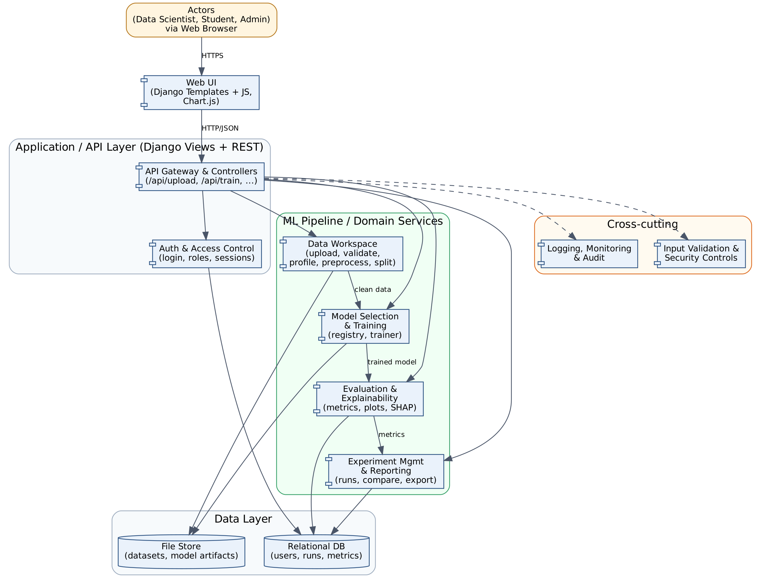
Figure 1: Component diagram. Solid arrows are runtime dependencies; dashed arrows are cross-cutting concerns applied by the API layer.

3.4 Component Descriptions
Component | Responsibility | Maps to Jira epic
Web UI | Renders pages for upload, model selection, training status, results and history. Charts (confusion matrix, metric bars) use Chart.js. Contains no business logic. | WBMME-4 to WBMME-7 (UI parts)
API Gateway & Controllers | Single entry point for all requests (/api/upload, /api/train, /api/evaluate, /api/runs). Validates input, checks authorisation, delegates to services, returns JSON. | All
Auth & Access Control | Registration, login, session handling (30 minute expiry, login throttling, CSRF protection) and role-based access (Data Scientist, Student, Admin). Ensures users only see their own datasets and runs. | WBMME-11
Data Workspace | Accepts CSV upload, validates type, size and schema, profiles the data, handles missing values and categorical encoding, and creates the train/test split. | WBMME-4
Model Selection & Training | Holds a registry of supported scikit-learn models and their hyperparameters. Trains the selected model(s) on the prepared data and stores the trained artifact. | WBMME-5
Evaluation & Explainability | Computes accuracy, precision, recall, F1, ROC-AUC (when the model gives probabilities) and the confusion matrix. Lists feature importance for models that provide it (Logistic Regression, Decision Tree, Random Forest). | WBMME-6
Experiment Management & Reporting | Records every run (dataset, model, parameters, metrics), supports side-by-side comparison, and exports a run or comparison as a CSV file (cells that start with = + - @ are neutralised). | WBMME-7
Logging, Monitoring & Audit | Structured logs of requests, training jobs, failures and admin actions. Never logs raw data values or credentials. | WBMME-11 (and WBMME-9 for deployment logs)
Input Validation & Security Controls | Central file validation (type, size, rows, columns), request-size limit, per-user rate limiting, job quota and time-out, and safe model serialisation. | WBMME-11
Relational DB | Stores users, roles, dataset metadata, runs and metrics. | WBMME-4 to WBMME-7
File Store | Stores uploaded datasets and trained model artifacts in per-user directories outside the web root. | WBMME-4, WBMME-5

3.5 Chosen Architecture Pattern and Rationale
Chosen pattern: Layered architecture (Presentation, Application/API, ML Pipeline/Domain, Data) with the Django MVT structure inside the web tier and a pipe-and-filter style ML pipeline (Upload, Preprocess, Train, Evaluate, Record).
Rationale:
- Separation of concerns: UI changes do not affect ML code, and a model can be swapped without touching the views.
- Matches the workflow. The ML flow is naturally sequential, so each stage is a replaceable component with a defined input and output.
- Fits the team: four students and a two-sprint schedule. A single deployable unit keeps CI/CD, debugging and the demo simple.
- Testable: each layer can be unit-tested with stubs, which supports the Test Plan's unit, integration and system levels.
Alternatives considered and rejected:
Alternative | Reason rejected
Microservices | Needs service discovery, inter-service auth and multiple deployments. Too much overhead for the team size and the sprint length.
Single-file monolith (no layers) | Fastest to start, but couples UI and ML code and makes parallel work on four branches cause merge conflicts.
Client-side ML (in-browser) | Limits model choice and dataset size, and is hard to secure and test.

3.6 Technology Stack and Data Stores
Area | Choice | Why
Language / Backend | Python 3.11, Django 5 | Same language as the ML libraries; built-in auth, ORM, CSRF protection.
API style | Django views returning JSON (Django REST Framework optional) | Simple, documented endpoints for upload, train, evaluate.
Frontend | Django templates, JavaScript, Chart.js | No separate build chain; enough for dashboards.
ML libraries | pandas, scikit-learn, joblib (four classifiers: Logistic Regression, k-NN, Decision Tree, Random Forest) | Standard, well documented, many classic models.
Relational DB | SQLite (development), PostgreSQL (optional deployment) | Zero-setup locally; production-ready option.
File store | Local per-user directories (outside web root) | Holds datasets and model artifacts; can later move to object storage.
Background jobs | Python background worker; Celery is optional and not committed in the SRS | Keeps the UI responsive during long training.
CI/CD & quality | GitHub Actions, pytest, pytest-cov, flake8/SonarQube | Required by the guidelines; runs tests on every PR.
Packaging / Deployment | Docker (WBMME-9) | Portable, reproducible environment.
Security libs | Django auth, bcrypt/PBKDF2, HTTPS (TLS 1.2+) | Standard, audited components.

3.7 Risks and Mitigations
ID | Risk | Severity | Mitigation
R1 | Long training times on large datasets block the UI or time out | High | Limit dataset size and rows; run training in a background job; show progress; set a timeout.
R2 | Malicious or malformed uploads (wrong type, huge file, formula injection in CSV) | High | Whitelist .csv, check MIME type and size, parse with pandas in a safe mode, never execute content.
R3 | Unsafe loading of pickled/joblib model files can run arbitrary code | High | Only load artifacts the system itself created; store them per user; never accept uploaded model files.
R4 | Data leakage or overfitting gives misleading results | Medium | Fit preprocessing only on the training split; report train and test metrics; document the method.
R5 | Team members unfamiliar with Git/Django cause delays and merge conflicts | Medium | Branch per feature, small PRs, reviews by repo owner, pair on first PR, shared task board.
R6 | Different library versions break the build between machines | Medium | Pin versions in requirements.txt; use Docker and CI to catch drift.
R7 | Users' datasets visible to other users | High | Per-user ownership checks on every query and file path; tests for access control.
R8 | Sprint timeline is too short for all epics | High | Prioritise by epic order; implement a minimal end-to-end flow first; defer feature importance and CSV export if needed.

3.8 Traceability to Requirements
Req ID | Requirement (short) | Architecture component | Design reference
MLE-F-001 | User registration and login | Auth & Access Control | DS-Auth-01 (4.2 login sequence)
MLE-F-002 | Role-based access (Data Scientist, Student, Admin) | Auth & Access Control | DS-Auth-02
MLE-F-003 | Upload CSV dataset | Data Workspace, File Store | DS-Data-01 (4.2 upload sequence, /api/upload)
MLE-F-004 | Preview and profile the dataset | Data Workspace | DS-Data-02
MLE-F-005 | Handle missing values and encode categories | Data Workspace | DS-Data-03
MLE-F-006 | Configure train/test split | Data Workspace | DS-Data-04
MLE-F-007 | Select a model from the catalogue | Model Selection & Training | DS-Model-01
MLE-F-008 | Configure hyperparameters | Model Selection & Training | DS-Model-02
MLE-F-009 | Train a model and show status | Model Selection & Training | DS-Model-03 (/api/train)
MLE-F-010 | Compute accuracy, precision, recall, F1 | Evaluation & Explainability | DS-Eval-01 (/api/evaluate)
MLE-F-011 | Show confusion matrix and plots | Evaluation & Explainability, Web UI | DS-Eval-02
MLE-F-012 | Feature importance / explanation | Evaluation & Explainability | DS-Eval-03
MLE-F-013 | Save each run (history) | Experiment Mgmt & Reporting, DB | DS-Exp-01
MLE-F-014 | Compare runs side by side | Experiment Mgmt & Reporting | DS-Exp-02
MLE-F-015 | Export results report | Experiment Mgmt & Reporting | DS-Exp-03
MLE-F-016 | Admin manages users and datasets | Auth & Access Control, Web UI | DS-Admin-01
MLE-NF-001 | Upload of up to 10 MB processed in 5 s or less | Data Workspace | Performance budget in 3.7 R1
MLE-NF-002 | Training of standard models on up to 50,000 rows completes in 60 s or less | Model Selection & Training | Background job design
MLE-NF-003 | Pages load in 3 s or less for 20 concurrent users | API Gateway, Web UI | Layered stateless API
MLE-NF-004 | Runs on Windows, Linux and macOS via Docker | Packaging | 3.6 Docker
MLE-NF-005 | Usable by a first-time user without training | Web UI | 4.5 UX Design
MLE-NF-006 | Failed jobs are contained (no partial model); saved data survives a restart | Model Selection & Training, Relational DB, Logging & Audit | 3.7 R1; 4.4 Error Handling
MLE-NF-007 | At least 20 datasets and 100 runs per user; lists paginated at 20 items | Data Workspace, Experiment Mgmt & Reporting, Relational DB | Pagination in list endpoints
MLE-SR-001 | Passwords stored hashed | Auth & Access Control | SAD 3.9 Spoofing
MLE-SR-002 | All traffic over HTTPS (TLS 1.2+) | Deployment / Gateway | SAD 3.9 Information disclosure
MLE-SR-003 | Uploads validated for type, size and content | Input Validation & Security Controls | SAD 3.9 Tampering
MLE-SR-004 | Only system-created model artifacts are loaded | Model Selection & Training | SAD 3.9 Tampering / EoP
MLE-SR-005 | Per-user data isolation and audit log of actions | Auth, Logging & Audit | SAD 3.9 Repudiation, Info disclosure
MLE-SR-006 | Request-size, rate, job-quota and run-time limits | API Gateway, Input Validation & Security Controls, Model Selection & Training | SAD 3.9 Denial of service
MLE-SR-007 | Session expiry, login throttling, secure cookies and CSRF protection | Auth & Access Control | SAD 3.9 Spoofing, Tampering
MLE-SO-001 | Confidentiality of datasets, models and results | Auth & Access Control, File Store, API Gateway | SAD 3.9 Information disclosure
MLE-SO-002 | Integrity of uploaded data, models and metrics | Input Validation & Security Controls, Model Selection & Training | SAD 3.9 Tampering
MLE-SO-003 | Availability against abusive or oversized requests | Input Validation & Security Controls, API Gateway, Model Selection & Training | SAD 3.9 Denial of service

3.9 Security Architecture
Security objectives (identical to SRS section 5.1.1: MLE-SO-001 Confidentiality, MLE-SO-002 Integrity, MLE-SO-003 Availability): (1) Confidentiality of each user's datasets, models and results. (2) Integrity of uploaded data, trained models and reported metrics. (3) Availability of the service against abusive or oversized requests. These are delivered under the Core Platform & Security epic (WBMME-11).
Threat modelling with STRIDE:
Threat | ML Evaluator scenario | Mitigation (component)
Spoofing | Attacker logs in as another user or reuses a stolen session | Hashed passwords (PBKDF2/bcrypt), 30 minute session expiry, login throttling, secure and HttpOnly cookies (Auth). Requirements: MLE-SR-001, MLE-SR-007
Tampering | Malicious CSV or modified model file changes results or runs code | File type, size and content validation; store artifacts outside web root; load only system-generated artifacts; no unpickling of user files; CSRF tokens on state-changing requests (Input Validation, Model Training). Requirements: MLE-SR-003, MLE-SR-004, MLE-SR-007
Repudiation | User denies deleting a dataset or an admin denies a change | Audit log of logins, uploads, trainings, deletions and admin actions with user ID and timestamp (Logging & Audit). Requirement: MLE-SR-005(b)
Information disclosure | One user reads another user's datasets or runs; sensitive data in logs or errors | Ownership check on every query and file path; HTTPS (TLS 1.2+); generic error messages; no raw data in logs (API, Auth, Logging). Requirements: MLE-SR-002, MLE-SR-005(a)
Denial of service | Huge uploads or many concurrent training jobs exhaust the server | Upload size limit, row/column limits, rate limiting, per-user job quota, training timeout (API, Input Validation). Requirement: MLE-SR-006
Elevation of privilege | Student reaches admin pages or APIs | Role-based access control on every view and endpoint; admin routes separated; deny by default (Auth). Requirements: MLE-F-002, MLE-F-016, MLE-SR-004

Trust boundaries: (a) browser to server (untrusted input, HTTPS required); (b) API layer to ML services (all data already validated); (c) application to file store and database (access only through the data layer).

4. Design

4.1 Design Overview
The design follows the layered architecture chosen in 3.5. A request travels Web UI, API Gateway, a service component (Data Workspace, Model Selection & Training, Evaluation, Experiment Management), and then the Relational DB and File Store. The API Gateway applies authentication, authorisation, CSRF checks, rate limiting and request-size limits before any service runs, so no service has to repeat them.
Main design decisions:
- Every dataset, run and result row carries an owner (user ID); every query and file path is filtered by that owner (MLE-SR-005).
- Training runs as a background job. The API returns a run ID immediately and the UI polls the run status; a job that fails or exceeds 300 s leaves no partial model (MLE-NF-006).
- Preprocessing (missing values, encoding, scaling) is fitted on the training split only, to avoid data leakage.
- Models are stored only as files created by the system under the owner's directory, and are loaded only from there (MLE-SR-004).
- Model types and hyperparameter ranges come from one registry (SRS Table 4.3-1), so the UI form, the validator and the trainer use the same source.
Main data entities and their relationships are shown in Figure 2.
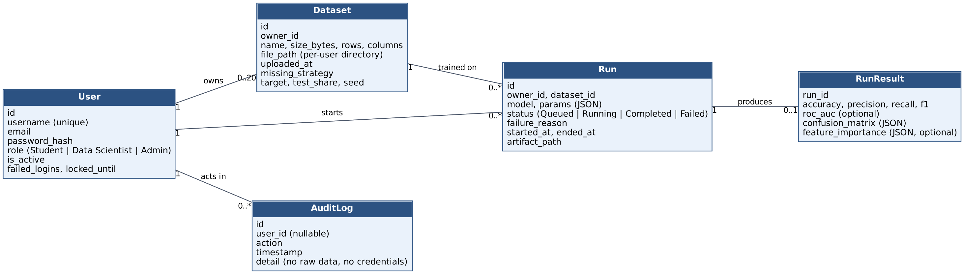
Figure 2: Class diagram of the main data entities (User, Dataset, Run, RunResult, AuditLog).
Notes on the entities: a User owns many Datasets and Runs. A Run refers to exactly one Dataset and has at most one RunResult (absent while queued, running or failed). AuditLog entries are written by the Logging & Audit component and are never edited by users.

4.2 UML Sequence Diagrams
Three key interactions are shown: login (SD-1), dataset upload (SD-2) and training with metrics (SD-3). Participants are the components of the component diagram in 3.3.
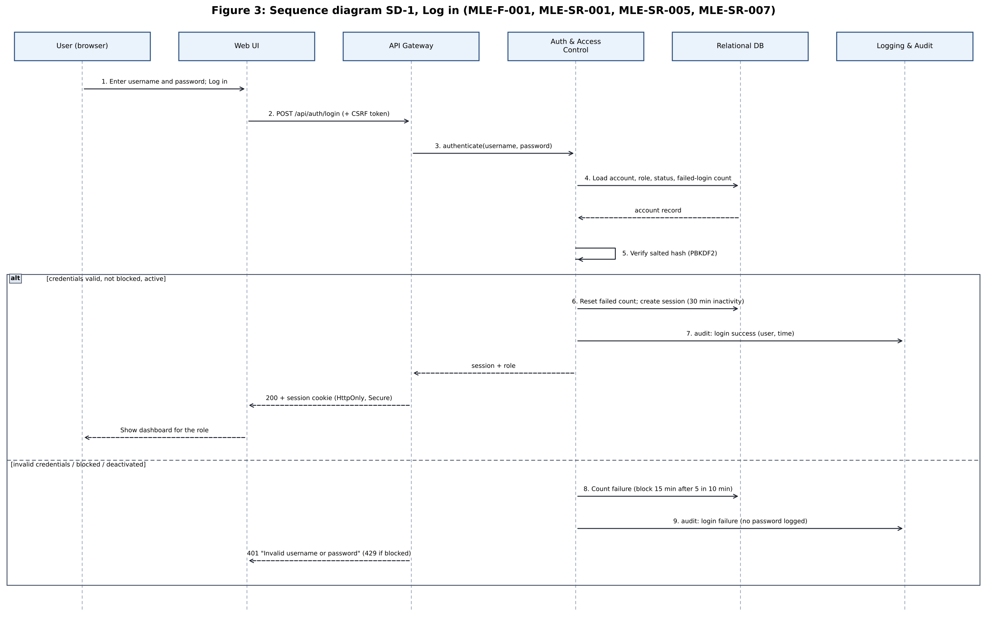
Figure 3: Sequence diagram SD-1, Log in.
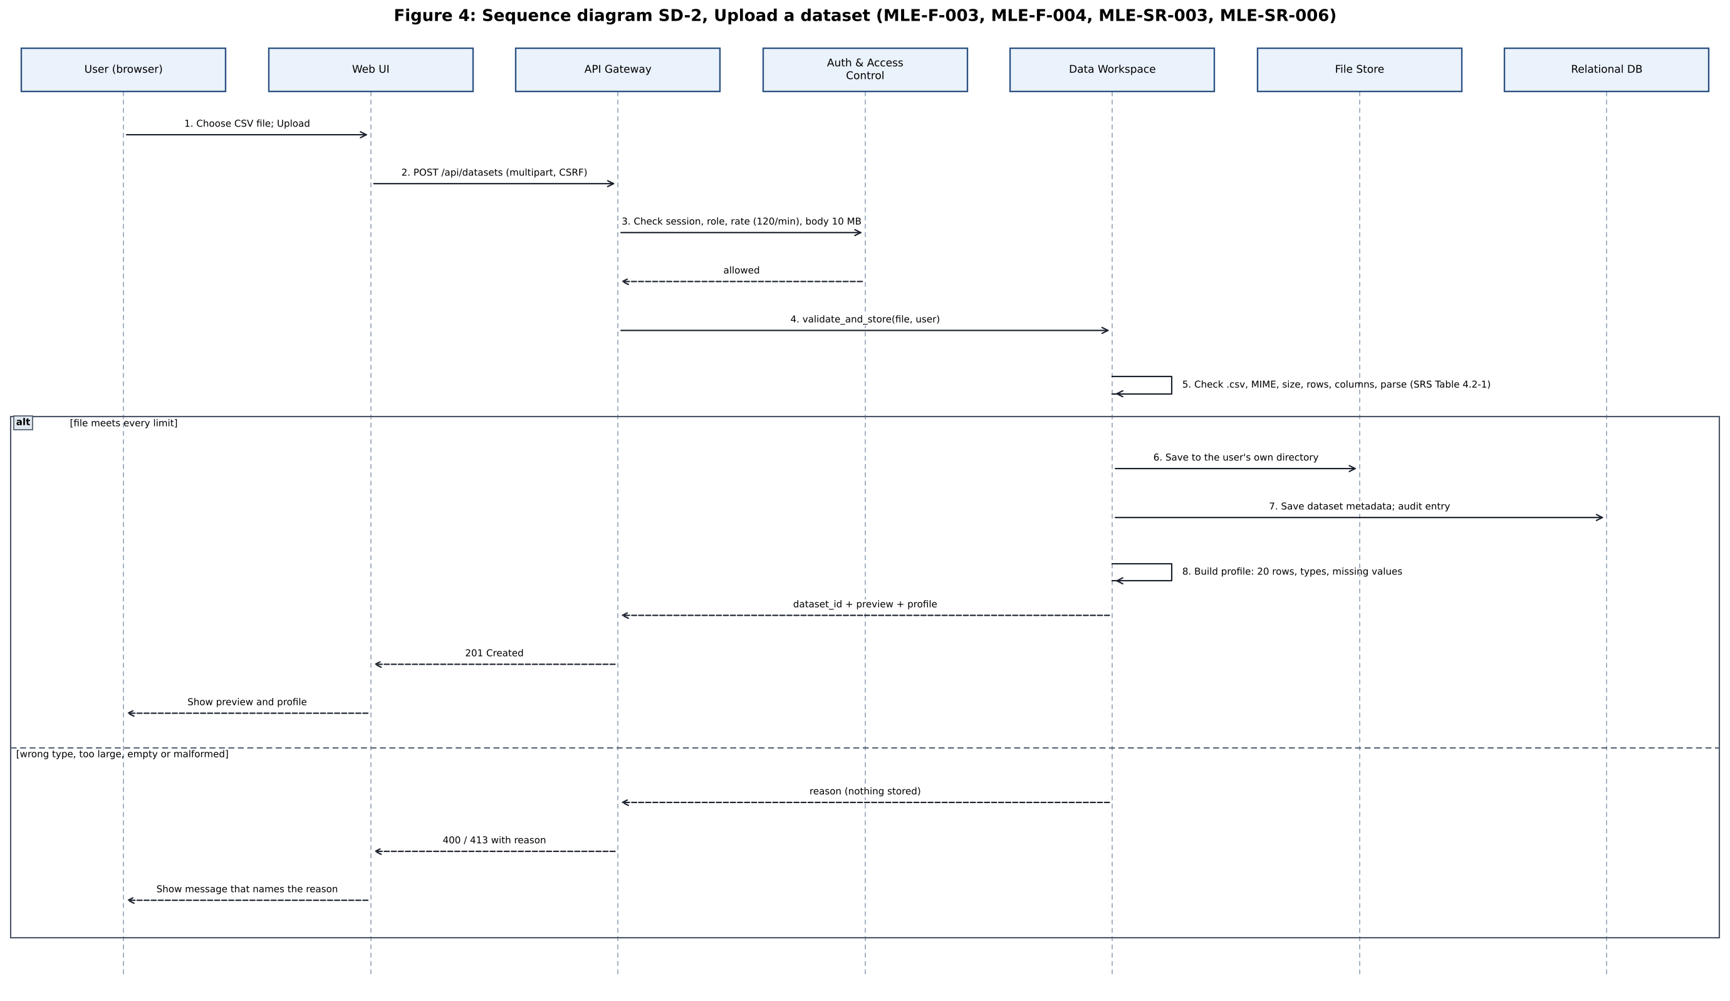
Figure 4: Sequence diagram SD-2, Upload a dataset.
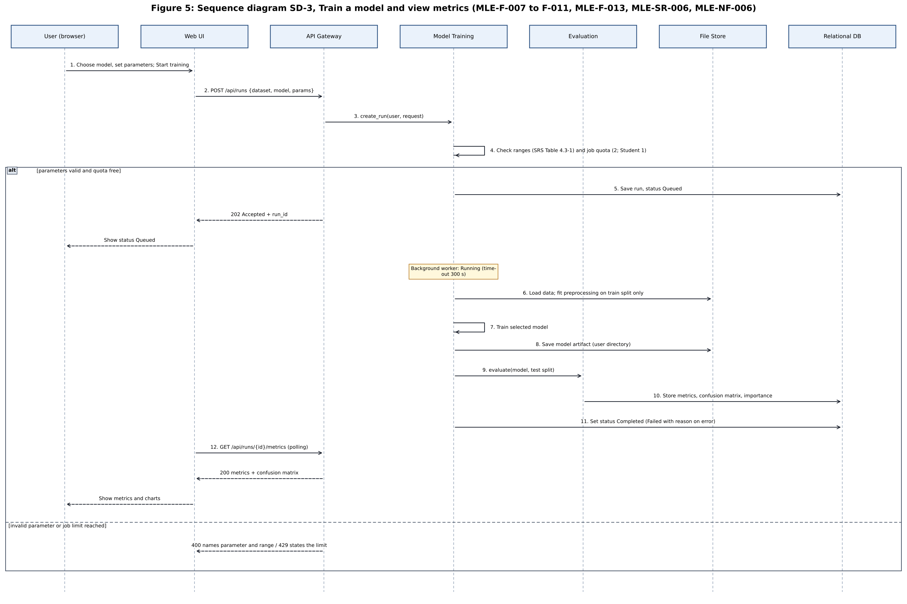
Figure 5: Sequence diagram SD-3, Train a model and view metrics.

4.3 API Design
All endpoints return JSON, require a valid session (except register and login), and require a CSRF token for POST, PATCH and DELETE. Common failure codes are described in 4.4. Lists are paginated at 20 items per page (MLE-NF-007).
Component 1: Auth & Access Control
Method | Endpoint | Request | Response / errors
POST | /api/auth/register | username, email, password, role (Student or Data Scientist) | 201 with user ID; 400 on weak password or duplicate user.
POST | /api/auth/login | username, password | 200 and session cookie (Secure, HttpOnly, 30 min); 401 on wrong credentials; blocked for 15 min after 5 failures in 10 min.
POST | /api/auth/logout | none | 204; session destroyed.
GET | /api/admin/users | page (Admin only) | 200 list of users; 403 for other roles.
PATCH | /api/admin/users/{id} | role or active flag (Admin only) | 200 updated user; 403 for other roles; change written to the audit log.

Component 2: Data Workspace
Method | Endpoint | Request | Response / errors
POST | /api/datasets | multipart CSV file (at most 10 MB) | 201 with dataset ID, 20-row preview and profile (types, missing values); 400 for wrong type, empty or malformed file or limits exceeded (20 to 50,000 rows, 2 to 100 columns); 413 if body over 10 MB.
GET | /api/datasets | page | 200 list of the caller's datasets only.
GET | /api/datasets/{id} | none | 200 metadata, preview and profile; 404 if not found or not owned by the caller.
DELETE | /api/datasets/{id} | none | 204; removes file and metadata; audit entry written.

Component 3: Model Selection & Training, Evaluation and Experiment Management
Method | Endpoint | Request | Response / errors
GET | /api/models | none | 200 catalogue of the four classifiers with hyperparameter names, defaults and allowed ranges.
POST | /api/runs | dataset ID, target column, model, hyperparameters, test split, missing-value and encoding options | 202 with run ID and status queued; 400 for out-of-range values or target with fewer than 2 or more than 20 classes; 429 if the active job limit is reached.
GET | /api/runs | page | 200 run history of the caller (dataset, model, parameters, status).
GET | /api/runs/{id} | none | 200 status (queued, running, completed, failed, timed out) and parameters; 404 if not owned.
GET | /api/runs/{id}/metrics | none | 200 accuracy, precision, recall, F1, ROC-AUC where available, confusion matrix and feature importance where available; 409 while the run is not completed.
GET | /api/runs/compare | ids (2 or more run IDs) | 200 side-by-side metrics and parameters.
GET | /api/runs/{id}/export | none | 200 CSV file; cells beginning with = + - or @ are neutralised.

Interface rules: the endpoint names above are the contract between the Web UI and the API; they are fixed at the start of Sprint 1 so that the front end and back end can be built in parallel.

4.4 Error Handling, Logging and Monitoring
Error handling
Code | Situation | Behaviour
400 | Invalid input (file type, size limits, hyperparameters, malformed CSV) | Nothing is stored; the response names the field and the rule that failed, with no stack trace.
401 | Not logged in or session expired | UI redirects to the login page; entered work is not lost on the server.
403 | Role not allowed or CSRF token missing or invalid | Request rejected and recorded in the audit log.
404 | Resource does not exist or belongs to another user | Same message for both cases so existence is not revealed.
409 | Metrics requested before the run completes | UI keeps polling and shows the current status.
413 | Request body over 10 MB | Rejected before the file is parsed.
429 | More than 120 requests per minute, or active job limit reached | Response states when to retry.
500 | Unexpected error | Generic message with a correlation ID; details only in the server log.

Training failures: if a job raises an error or exceeds 300 s, the run is marked failed or timed out, the partial model file is deleted, and the user sees a short reason. Data already saved (datasets, finished runs) is unaffected and survives a restart (MLE-NF-006).
Logging
- Structured application log (timestamp, level, user ID, request ID, component, message) for requests, training jobs and failures.
- Audit log in the database for logins, failed logins, uploads, deletions, training starts and admin changes (MLE-SR-005).
- Never logged: passwords, session tokens, and raw dataset values.
Monitoring
- A health endpoint (GET /health) returns 200 when the app and database respond; used by Docker and the demo.
- CI reports test results and coverage on every pull request; failed jobs and error counts are checked in the application log during testing.

4.5 UX Design
Design principles: one task per screen, a visible progress path, plain language, and error messages that say what to fix (MLE-NF-005: usable without training).
Screen | Content and behaviour
Register / Login | Short forms with inline validation; lockout message shows how long to wait.
Dashboard | Lists the user's datasets and recent runs, with buttons for Upload and New run. Admin sees a link to the admin console.
Upload | File picker with the rules (CSV, up to 10 MB) shown beside it; after upload shows a 20-row preview and column profile.
Prepare data | Choose the target column, missing-value and encoding options and the test split with defaults pre-filled.
Choose model | Four model cards; selecting one shows hyperparameters with defaults and allowed ranges; invalid values are flagged before submission.
Run status | Shows queued, running, completed, failed or timed out and refreshes automatically; Cancel is not offered in the committed scope.
Results | Metric cards, confusion matrix heat map, feature importance bar chart (Chart.js), and an Export CSV button.
History and Compare | Paginated run table; select two or more runs to open a side-by-side comparison.
Admin console | Users with role and active toggles; dataset overview; audit log view.
Flow: Login, Dashboard, Upload, Prepare data, Choose model, Run status, Results, then History or Compare. Accessibility basics: labels on all inputs, keyboard navigation, and chart values also shown in a table so colour is not the only cue.

4.6 Open Issues and Next Steps
# | Open issue | Next step
1 | Exact API field names and JSON shapes | Freeze in a shared API sheet at the start of Sprint 1; update 4.3 if they change.
2 | Background worker choice (thread or process pool versus Celery) | Start with a Python worker; revisit only if the 300 s time-out cannot be enforced reliably.
3 | Whether PostgreSQL is used in the demo or SQLite only | Decide with the team during Docker work (Sprint 2); no code depends on it.
4 | Optional features (SHAP, PDF report, Celery) | Not committed in the SRS; schedule only if time remains after Sprint 2 stories.
5 | Requirement changes from team review | Update 3.8 and 3.9 together with the SRS so IDs stay consistent.
6 | Test cases for MLE-NF-006, NF-007, SR-006 and SR-007 | Ask the Test Plan owner to add them to Test Plan section 3.

5. Appendices

5.1 Glossary
Term | Meaning
ADR | Architecture Decision Record: a short note recording an architecture decision and its reason.
API | Application Programming Interface: the set of endpoints the Web UI calls.
CI/CD | Continuous Integration and Continuous Delivery: automatic build and test on every push (GitHub Actions).
CSRF | Cross-Site Request Forgery: an attack that makes a logged-in browser send an unwanted request.
CSV | Comma-Separated Values file, the only upload format.
MVT | Model-View-Template, the structure of a Django web application.
ML | Machine learning.
NF | Non-functional requirement (MLE-NF-###).
RBAC | Role-Based Access Control: permissions depend on the user's role (Student, Data Scientist, Admin).
RTM | Requirements Traceability Matrix: maps requirements to design and tests.
SAD | Software Architecture Document (this document).
SO / SR | Security objective (MLE-SO-###) / security requirement (MLE-SR-###).
SRS | Software Requirements Specification.
STP | Software Test Plan.
STRIDE | Threat categories: Spoofing, Tampering, Repudiation, Information disclosure, Denial of service, Elevation of privilege.
TLS | Transport Layer Security, used for HTTPS.

5.2 References
- ISO/IEC/IEEE 42010: Systems and software engineering, Architecture description.
- OWASP Top 10 and OWASP Application Security Verification Standard (ASVS).
- NIST SP 800-160: Systems Security Engineering.
- WBMME Software Requirements Specification, Parts A and B, and Software Test Plan.
- Django 5 documentation (security, authentication, CSRF) and scikit-learn documentation (classifiers and metrics).
- PES University SE Mini-Project Guidelines 2026 and Deliverables Part-1 and Part-2.

5.3 Tools
Purpose | Tool
Diagrams | Graphviz (component and class diagrams); Python with matplotlib (sequence diagrams)
Implementation | Python 3.11, Django 5, pandas, scikit-learn, joblib, Chart.js
Version control and tracking | Git, GitHub (repository, issues, Project board, pull requests)
CI and quality | GitHub Actions, pytest, pytest-cov, flake8 or SonarQube
Testing | Selenium (UI), Postman (API), JMeter or Locust (performance), OWASP ZAP (security scan)
Packaging | Docker

